Practical 8 | N Queen | Date: 08/08 /2025
Aim: | To implement N Queen
Requirement: | Python IDE
Code: | 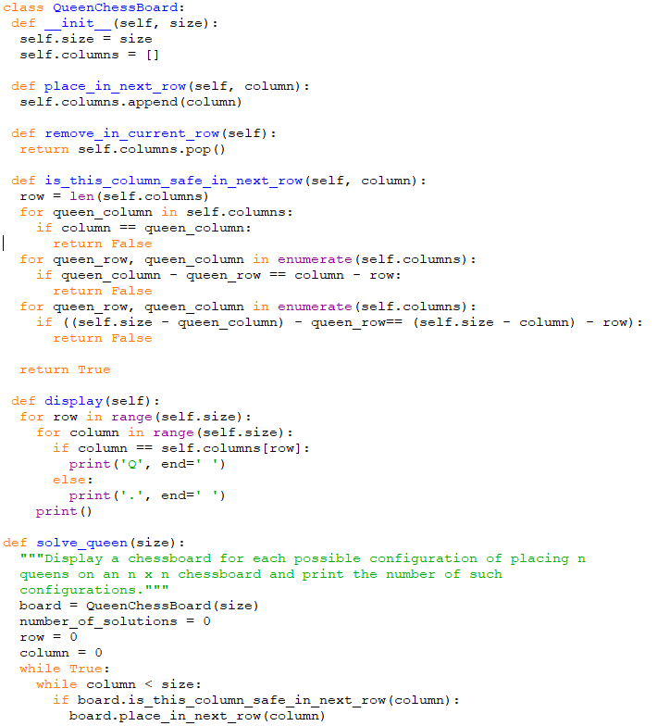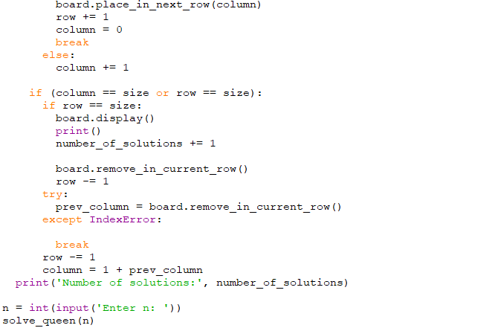
Screenshots: | 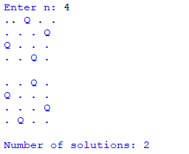
Result: | The particular N Queen has been implemented.
Date of Submission: |  | Sign:

